IAFRI Student Biogs:

Dr Alex Laverick
As an IAFRI student I studied Synthetic Biology, developing a new ambient temperature amplification method that could be used to detect crop viruses in-field. The IAFRI scheme allowed me to communicate with industrial scientists at FERA, who could contribute meaningfully both to my project and my career development. Additionally, the IAFRI scheme offers career development opportunities in the form of the IAFRI science conference that allows students and guests speakers a chance to present their work through posters and oral presentation. I am currently working as a post-doctoral researcher at Newcastle University continuing my work on plants.

Dr Yaiza Gutierrez
During my PhD, I focused on a real-life problem of Septoria fungicide resistance, a devastating disease affecting wheat crops. My research involved extensive analysis ranging from sample collection to fungicide sensitivity tests, high throughput sequencing and bioinformatic analyses. One of the most advantageous aspects of IAFRI was bridging the best from both industry and academia. This allowed me to gain practical insights into agricultural challenges while also benefiting from the academic environment. Additionally, IAFRI provided the opportunity to learn cutting-edge skills like modelling and bioinformatics, enhancing my capabilities as a researcher. Moreover, having access to the latest technology facilitated my research, enabling me to make meaningful contributions to the study of fungicide resistance on wheat crops. The knowledge and expertise I acquired during my PhD journey paved the way for my current role as Bioinformatics Integration Specialist at Veiovia Ltd., a spin out company from the University of York.

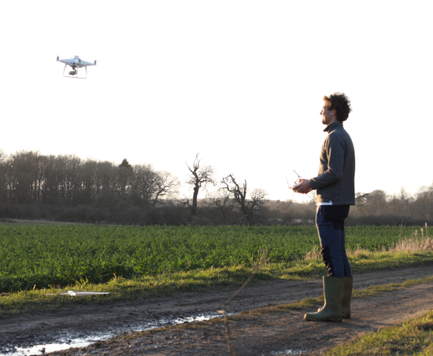
Nicholas Allen
My PhD is looking at practical ways of adopting new technologies for the agri-environment of hedgerows in the UK; a highly relevant field in terms of net zero, biodiversity and novel farming subsidies. This an area of interest to Fera too, not only on a policy side, but commercially, by enabling emerging environmental markets to measure, validate and report on carbon storage and biodiversity net gain. Fera’s network and expertise have helped shape the project by enabling discussions with key stakeholders ranging from conservation charities, to start-ups, right through to people involved with policy. The network also extended to large estates and landowners, giving me access to land to study on a scale I couldn’t have imagined when starting the PhD. I am now in the latter stages of the PhD with lots of industry context in mind, in terms of how this could be most beneficial and I am looking forward to take elements further post-PhD.

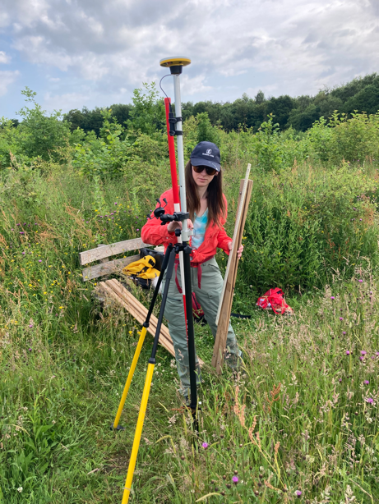
Broghan Erland
Within the 1st year of my PhD, Fera Science has provided me the opportunities to meet and build connections with key policy makers, stakeholders, and researchers which I never would have had with just a university alone. Those linkages have helped guide my research to be more effective in responding to the real problems faced by those in the field. The expertise and equipment available through the partnership with Fera Science has been an extremely useful asset to my project. I look forward to working with those at Fera Science to produce relevant and useful research.

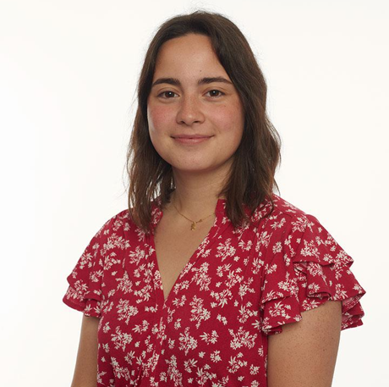
Dr Ines Vasquez
I completed my PhD in Plant Virology as part of IAFRI in 2021. Within my PhD project, the aim was to perform a baseline study on rose viruses present in the UK to clarify the current situation and help to future proof rose cultivation. During my research, I worked with multiple diagnostic methods including ELISA (Enzyme-linked immunosorbent assay), quantitative RT-PCR and High-Throughput Sequencing (HTS). It was the latter what opened the door for me, as I continued my career in this field, working as a Molecular Scientist at Fera Science Ltd. I am still working at Fera, as a Senior Molecular Scientist as part of the DST (Detection and Surveillance Team) as a project manager, organising and managing the delivery of molecular biology projects, writing and contributing to bids and scientific publications. By performing my PhD as part of IAFRI, I had access to new technologies at Fera Science Ltd., for example HTS platforms (MiSeq, MinION), and it also gave me the chance to see the daily work of a diagnostic laboratory. I had the opportunity to see closely how the industry works, but also still be involved in the university, keeping an academic perspective.

